Policies order in Main Policy page
https://www.hpladditives.com/about-policies-notice
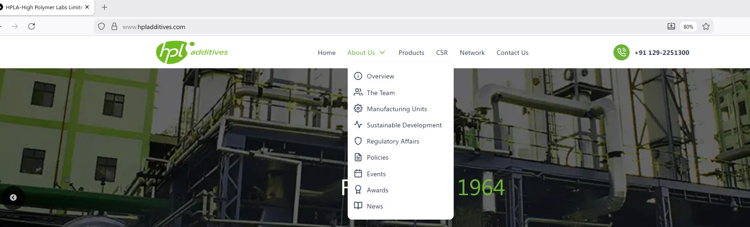

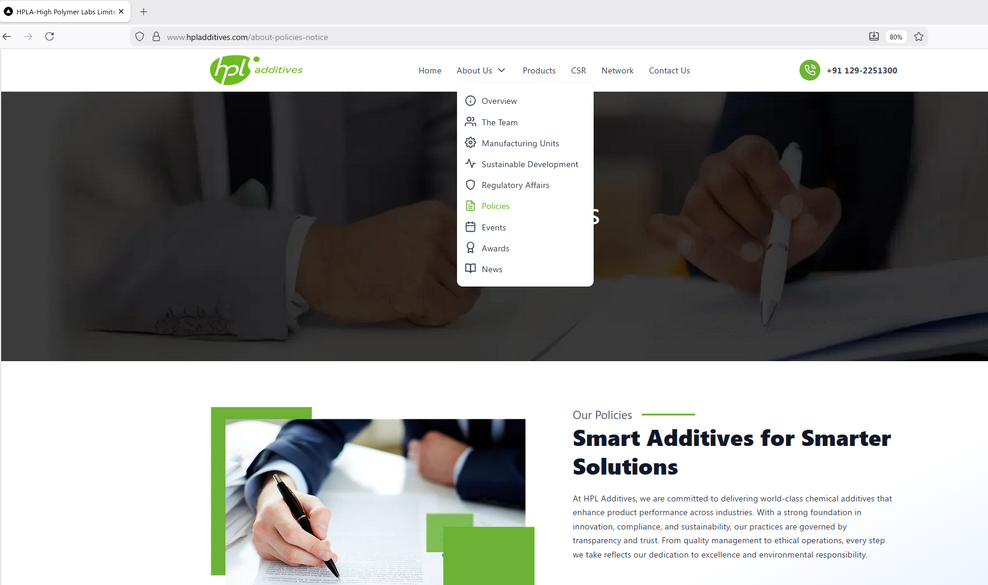

THE CORRECT ORDER OF POLICY NUMBER/ PLACEHOLDER

- HPL’s Sustainability Report- FY 2024-25
- CDP report 2025
- CDP report 2024
- HPL_PCF_Independent Limited Assurance Statement
- Independent Limited Assurance Statement -FY 2024-25
- Independent-Limited-Assurance-Statement- FY 2021-22 FY 2022-23 FY 2023-24
- ISO 9001 Certification
- ISO 14001 Certification
- ISO 45001 Certification
- Circular Economy Policy
- Climate Change Policy
- Energy Efficiency & Management Policy
- Environmental Management and Compliance Policy
- Health & Safety Policy
- Human Rights Policy
- Product Safety and Quality Policy
- Stakeholder Engagement Policy
- Waste Management Policy
- Water and Wastewater Management Policy
- Environment Policy
- Green Procurement Policy
- Supplier Code of Conduct
- Sustainable Supply Chain policy
- Living Wage Practices
- Fair Labour practices
- Code of Conduct
- Corporate Governance Policy
- Anti-Bribery and Anti-Corruption Policy
- Corporate Social Responsibility Policy
- Code Of Conduct Independent Directors
- Annual General Meeting Notice-FY 2024-25
- Annual General Meeting Notice-FY 2023-24
- Annual General Meeting Notice-FY 2022-23
- Annual General Meeting Notice-FY 2021-22
- Annual General Meeting Notice-FY 2020-21
- Annual Returns Form MGT_7- FY 2023-24
- Annual Returns Form MGT_7- FY 2022-23
- Annual Returns Form MGT_7- FY 2021-22
- Annual Returns Form MGT_7- FY 2020-21

